Basic

1. Check what's the type of the following values in the python:

○ 1 - Int

○ 3.14 - float

○ "Big Data!" - string

○ 'Big Data!' – string

○ True - bool

○ False - bool

○ [1,2,"intruder",3] - list

2. Write a script that prints the integers from 1 to 100. For multiples of three print "Fizz" instead , and for the multiples of five print "Buzz". For numbers which are multiples of both print "FizzBuzz".

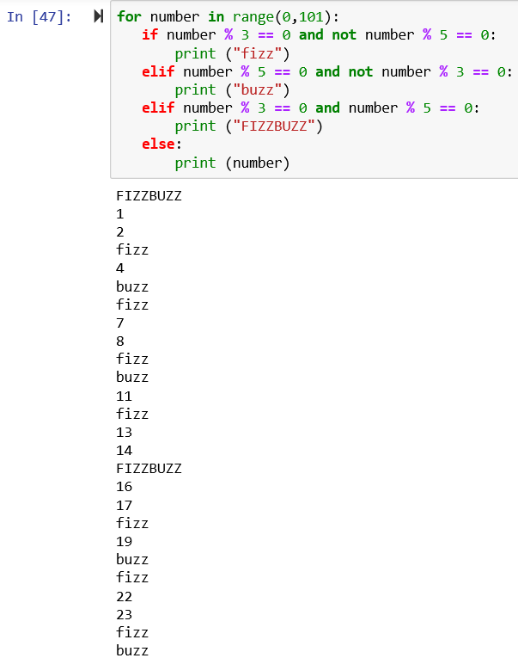 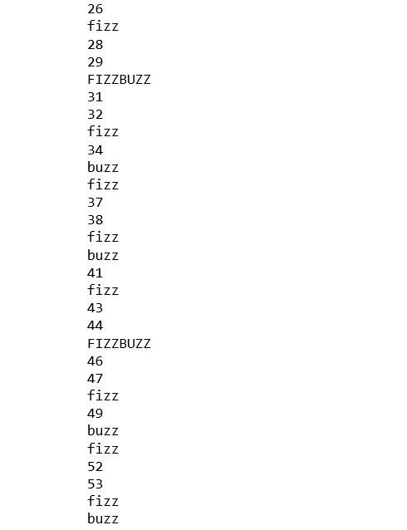 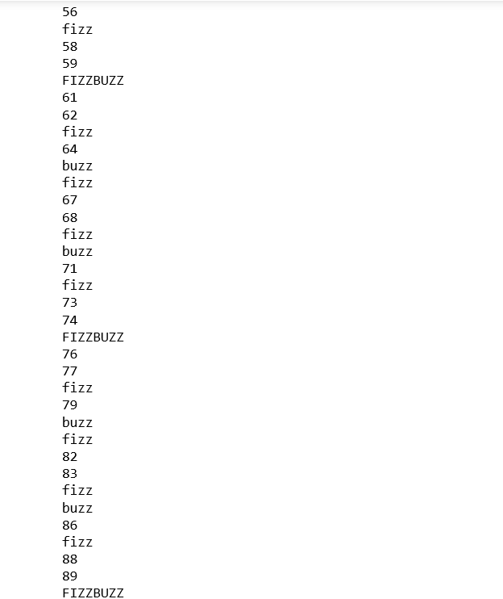 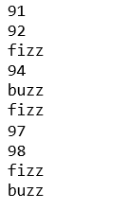

3. Could you find the maximum or minimum integer value in a list. If we list all the natural numbers below 10 that are multiples of 3 or 5, we get 3, 5, 6 and 9. The sum of these multiples is 23. Find the sum of all the multiples of 3 or 5 below 1000.

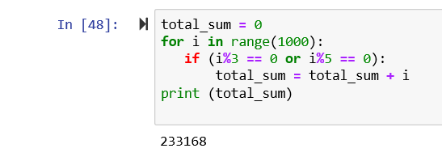

4. Write a script that takes out all the vowels and response with shortened version the string. Your script should not be case sensitive.

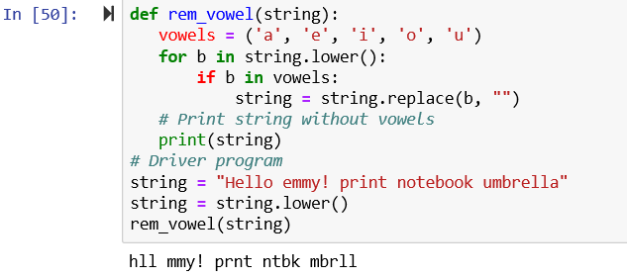

Advanced

1. Write a Python program to count the number of characters (character frequency) in a string. The expected results are two options: [Example: Babak Khosravifar] ○ Sorted by alphabetical order [{‘a’:4, ‘b’:2, ‘f’:1, ‘i’:1, …..}] ○ Sorted by the repetition of characters in descending order [{‘a’:4, ‘b’:2, ‘k’:2, ‘r’:2, …..}]

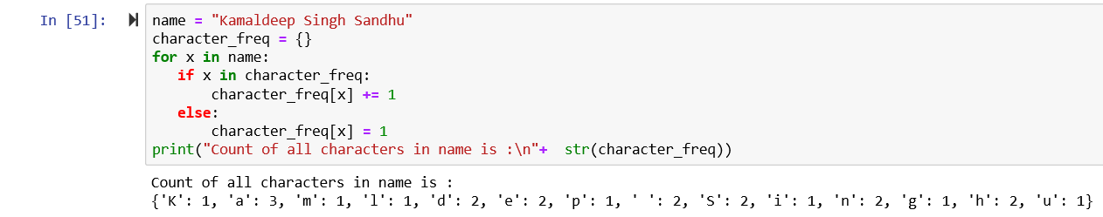

1. Write a Python program to count the occurrences of each word in a given sentence.

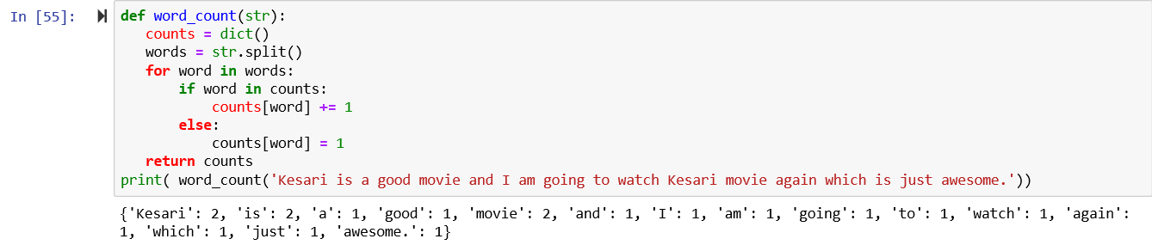

1. Write a Python program that accepts a comma separated sequence of words as input and prints the unique words in sorted form (alphanumerically)

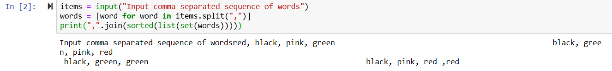

Reach

1. Write a program that reads two lists of numbers (4 items minimum) and merge them by sorting them out ignoring duplicates

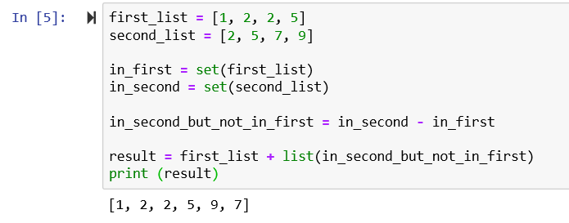

2. Improve the previous code by ignoring the ones that could be written as a linear combination of any other two numbers (13=2\*5+1\*3), so if 3 and 5 are there, you should drop 13 if seen